**Analysis Report**

This work has been conducted using python and jupyter notebook.

First, I imported the xlsx file using python pandas and got the data sets I targeted during preprocessing stages.

These four bar charts have been generated for the basic understanding of data characteristics.

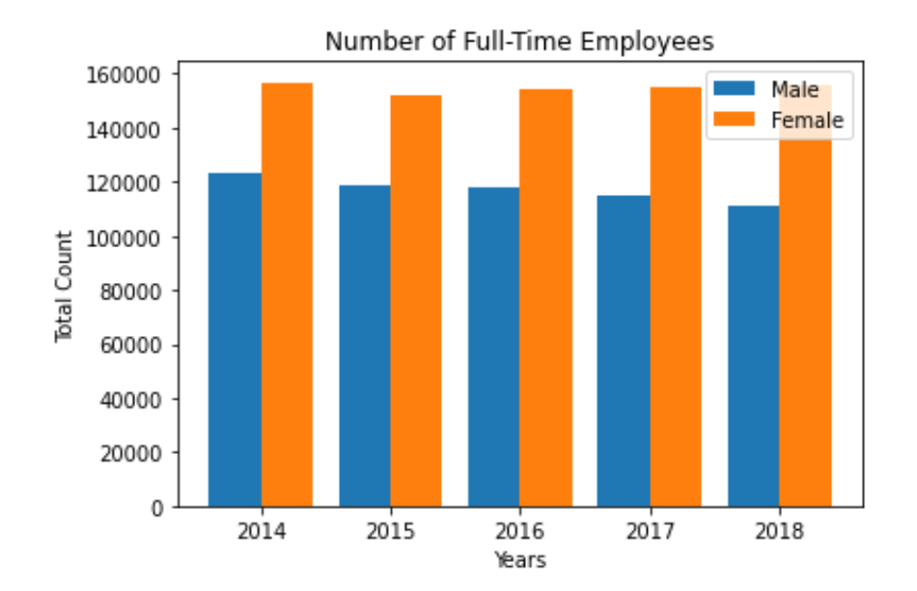

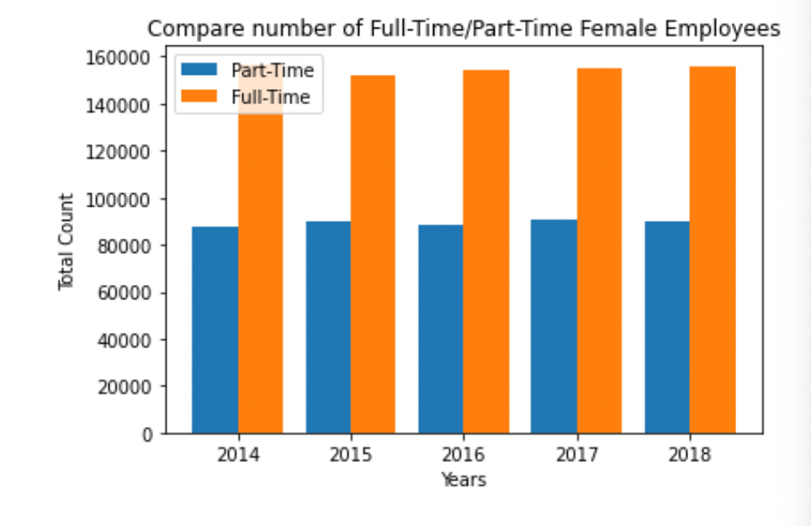

As shown in four charts, female employees are far more than males in both types of employment (male, female). And the full-time job is the dominant type of employment for both genders, especially males.

Although female part-time employment is more dominant than the males, it seems stable. While male part-time employment is slowly increasing. Therefore, for this kind of analysis male dataset can be more valuable than the female dataset. Also, male employment has more potential since it has lower people than females.

Now, let’s move on to the sector analysis.

There are ten clusters(sectors).

I divided the dataset into ten datasets only for the part-time employment for individual sector analysis.

1. **education**

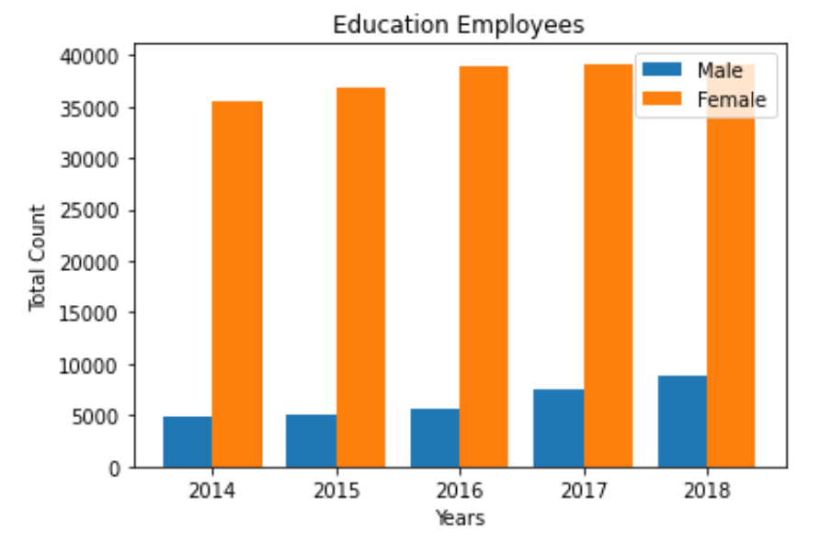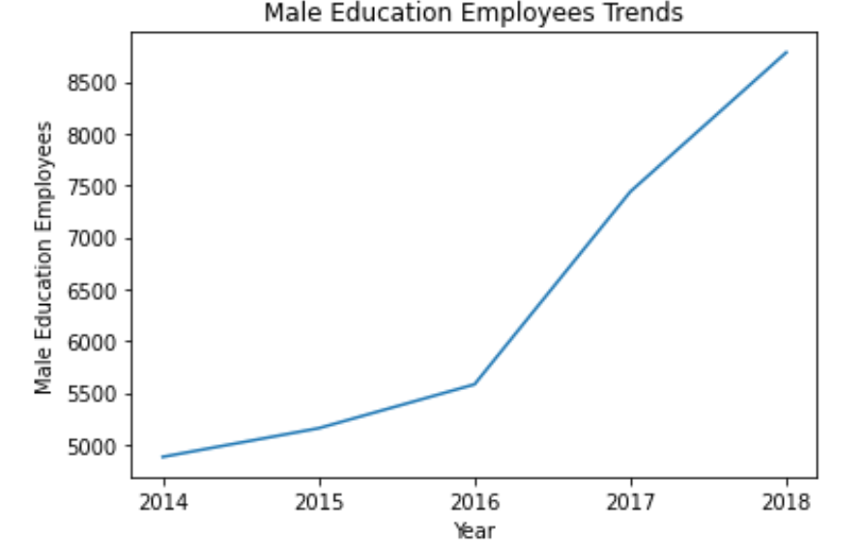

1. **Family**

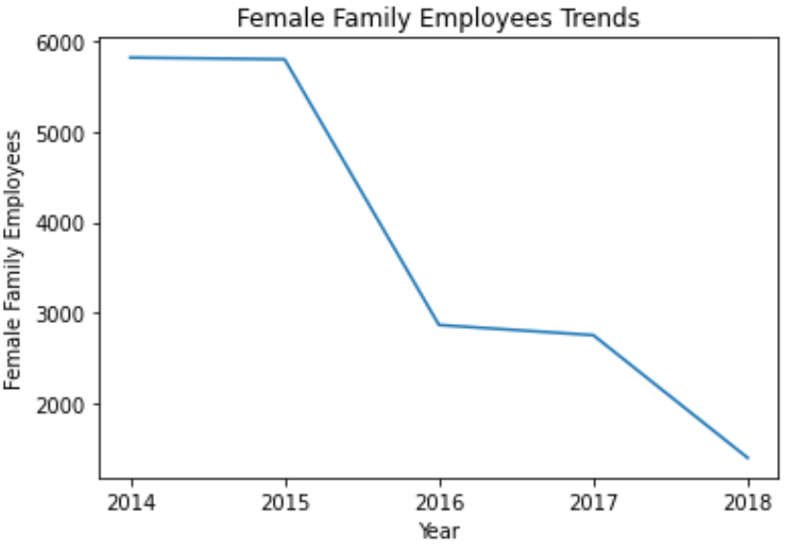

1. **Finance**

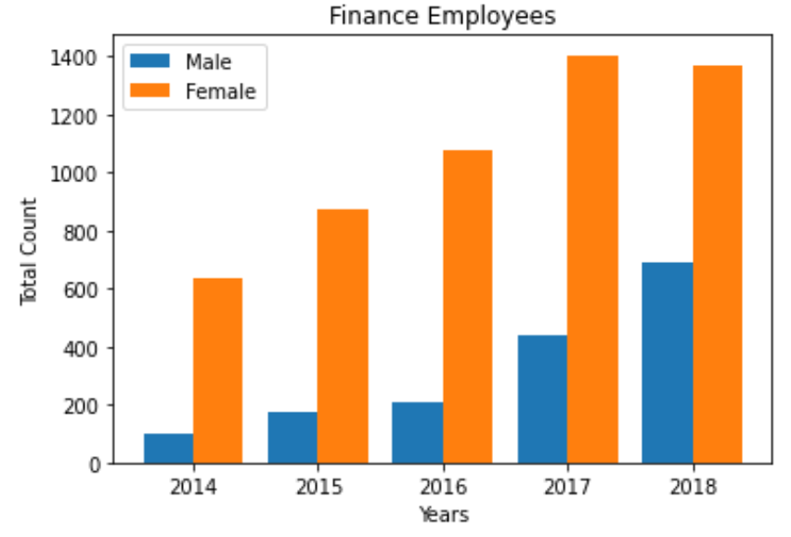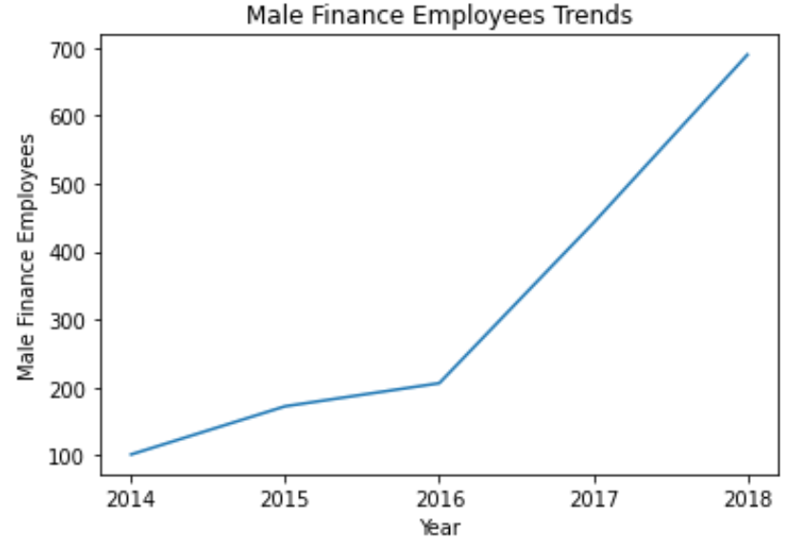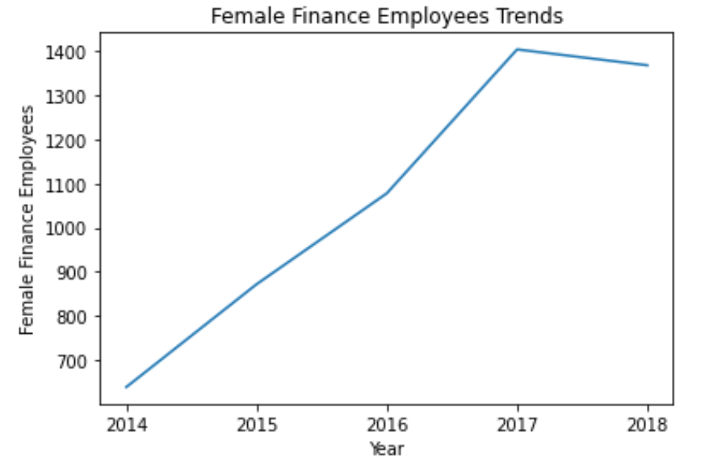

1. **Health**

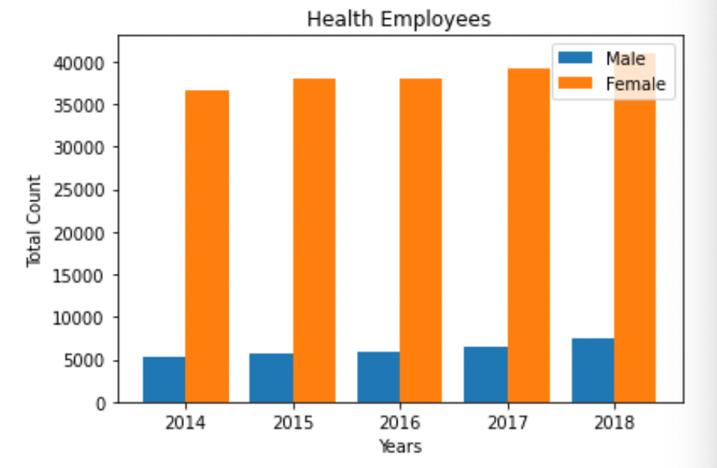

1. **Industry**

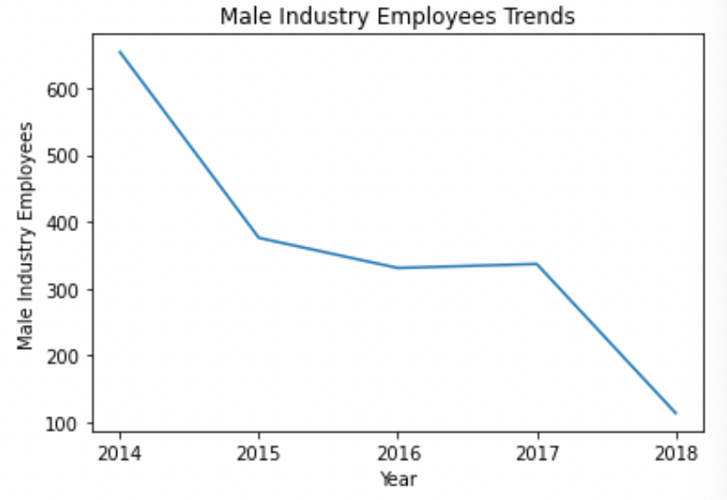

1. **Justice**

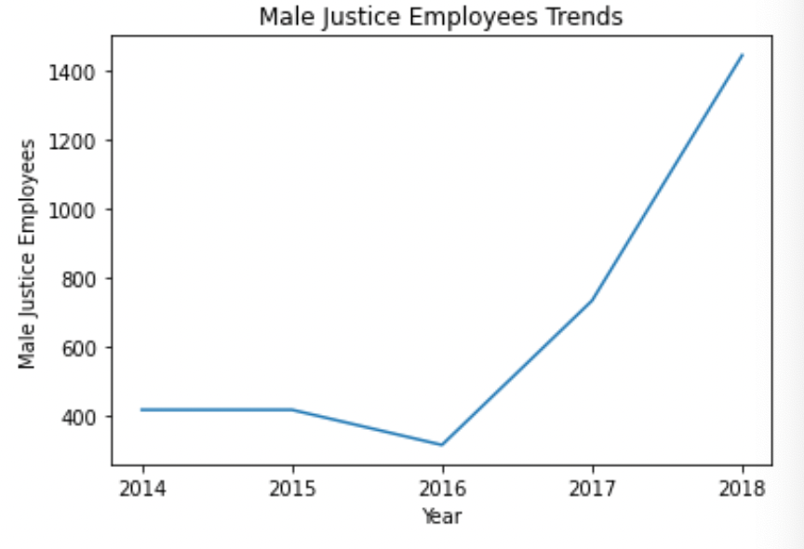

1. **Planning**

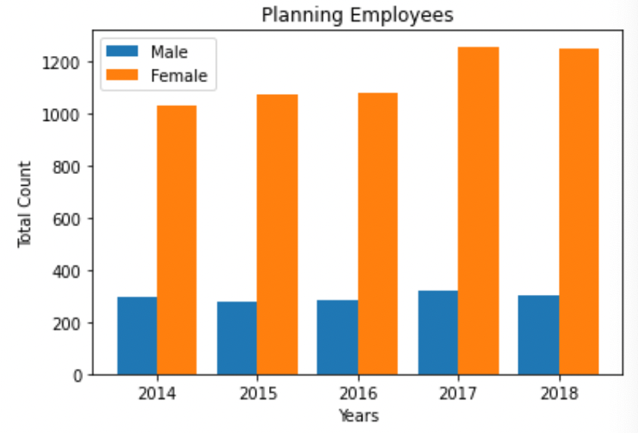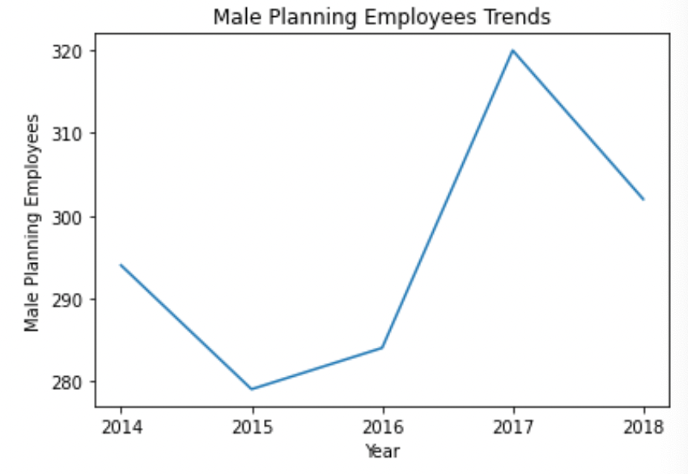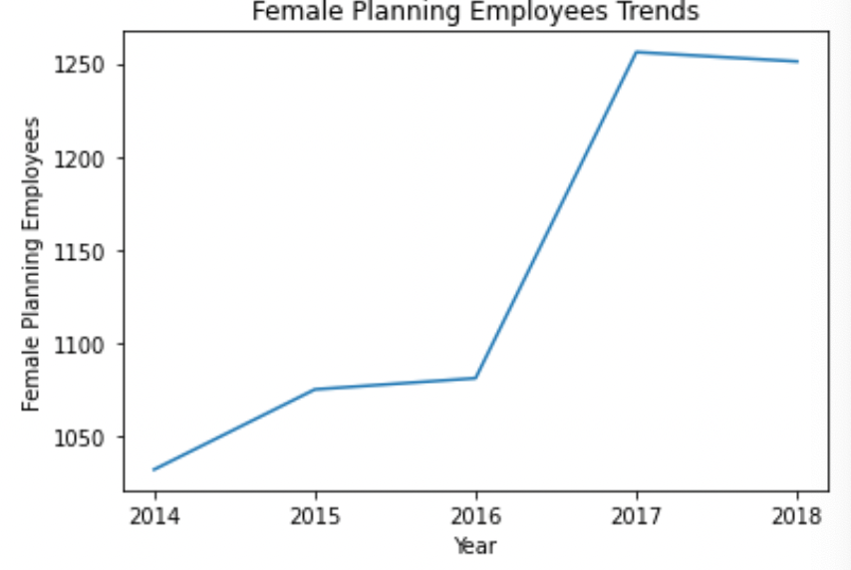

1. **Premier**

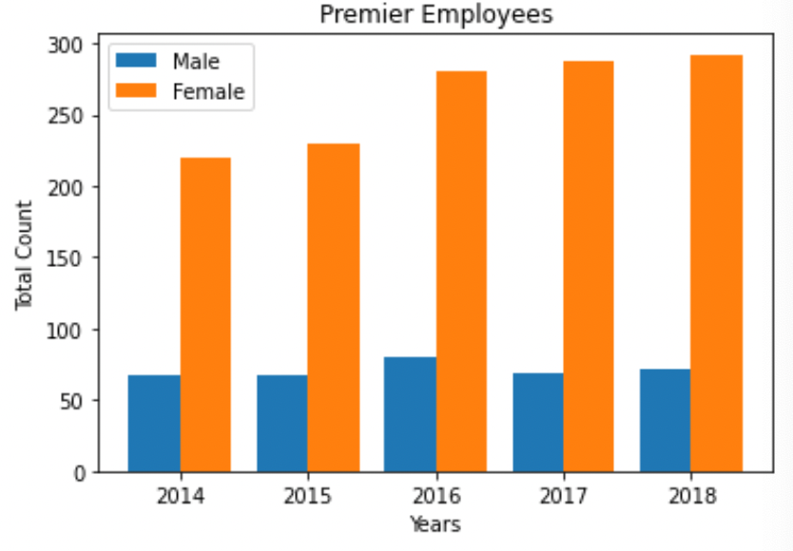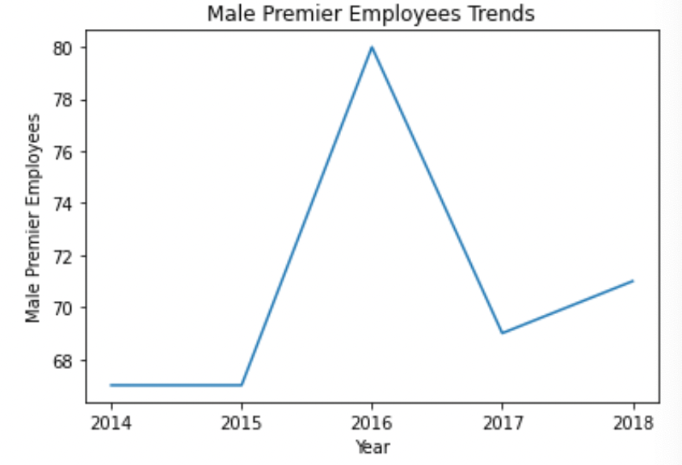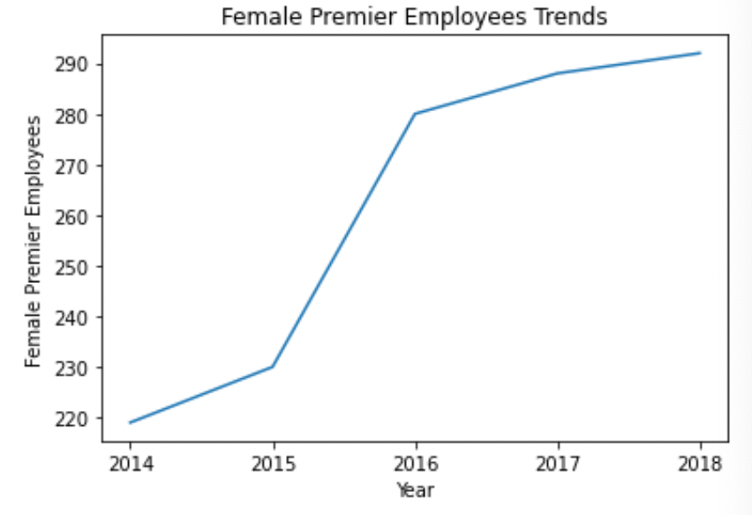

1. **Transport**

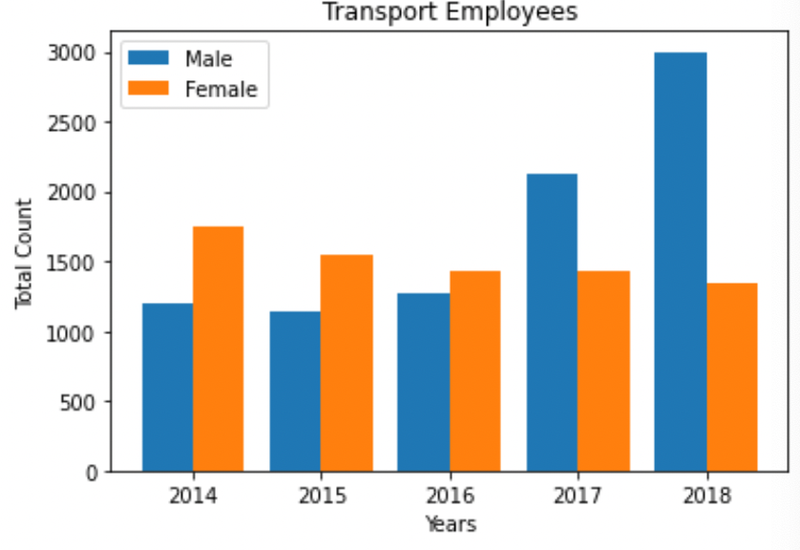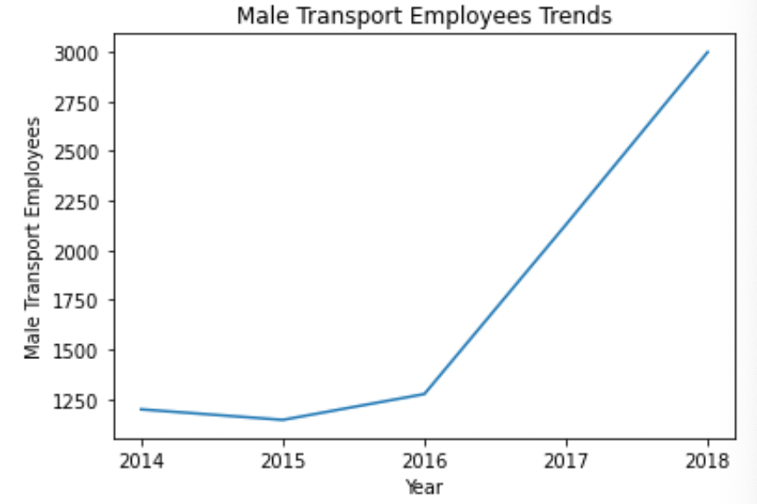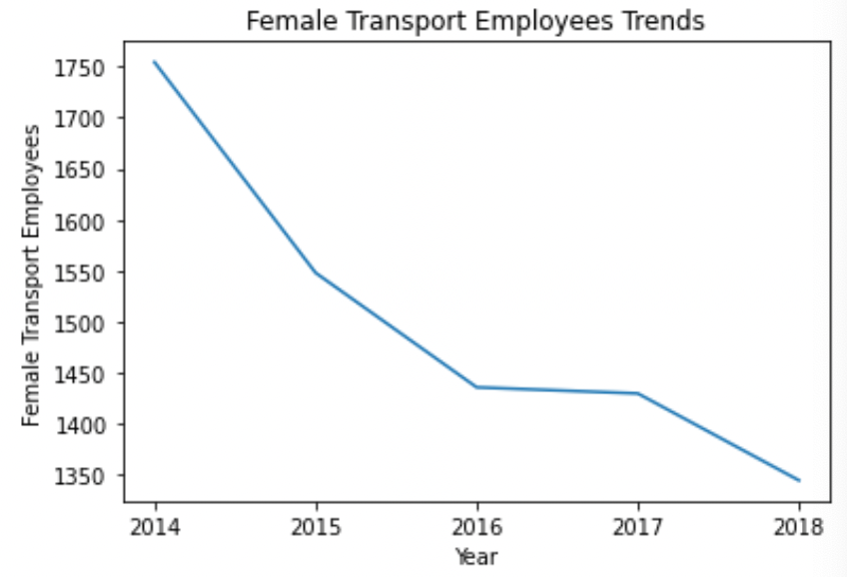

1. **Treasury**

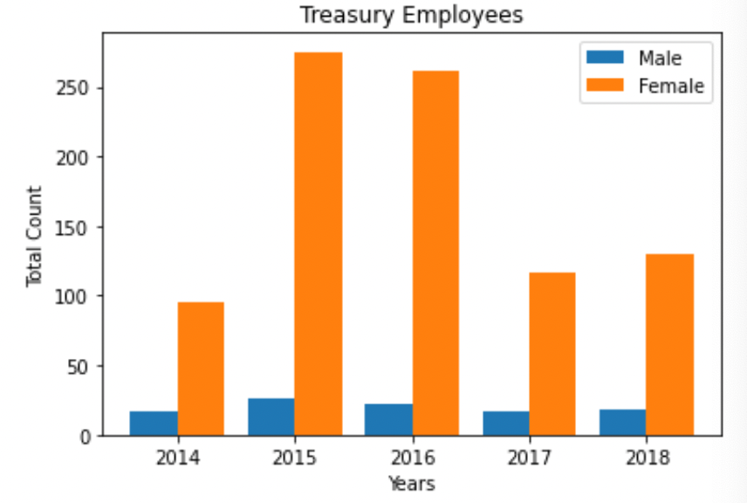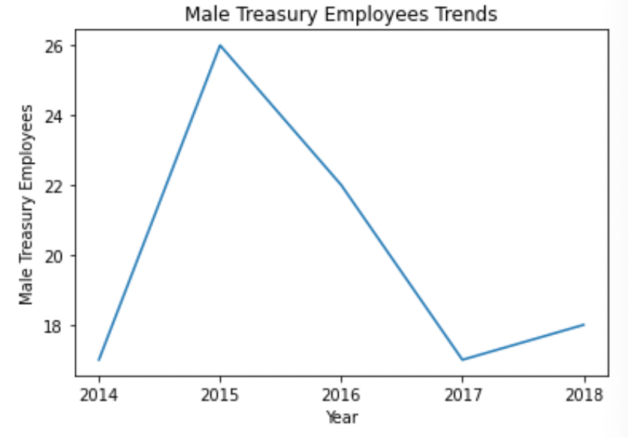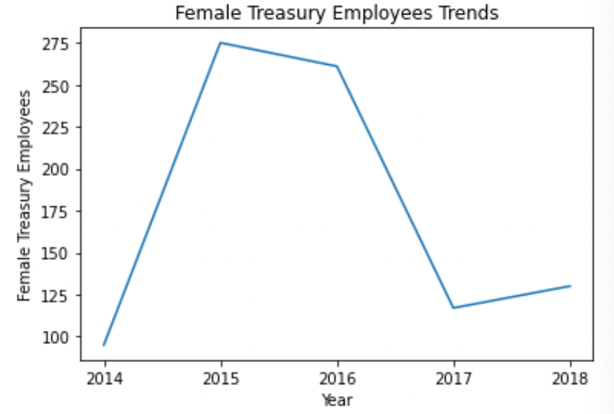

The above bar charts and line charts show that family and industry sectors present a strong downtrend. Therefore, we can easily tell these sectors(family, industry) are less important than the other sectors for our analysis.

Treasury, Premier, and Planning sectors have less than 1,200 employees annually. So these sectors have less potential and effects.

In the transport sector, male employees increase while females decrease, and it is the only sector where male employees are more than females.

Education, Finance, Health, and Justice sectors indicate a drastic increase, which means these sectors have potential and positive trends that can be persisted till 2025.